Table of Contents

**Next release Fixes Updates** 1

***Languages updated*** 1

***Tutorials Updated*** 2

**MSSQL - Set default language** 2

Unicode install and nounicode setting 2

***Unounicode=false*** 2

***Unounicode=true*** 3

***Colours Select for Reporting groups*** 4

***Customise Languages - Rest tab - Empty account / Empty Group*** 4

**Budgets MSSQL Error** 5

**Access control** 5

***Posting / Delete buttons*** 5

***Default language for a Set of Books*** 6

**Access Violations - Reports** 6

***Ledger analyser - Balance sheet*** 6

***Graphs*** 6

***Cost centres*** 6

**Export - Accounts** 6

***Spreadsheet import - Accounts*** 6

***Import Stock*** 7

**Imported Batches** 7

**Bank import - Import Bank statement** 7

***Delete Bank account with Posted transactions*** 7

***Bank-Import Open Item link*** 7

**Imported Documents** 8

***Import Exported documents*** 8

***Financial entry*** 8

***Update Documents*** 8

**Next release Fixes Updates**

***Languages updated***

Fixed typo in Afrikaans language file

LabelID 337 Verskafferreoere => Verskafferretoere missing "t".

Scheduled for next installs compile.

***Tutorials Updated***

All tutorials - Added the Compressor and Drill press images to Stock items for tutorial and documentation purposes.

These images were not included, since these tutorials was created from scratch on a blank database.

Scheduled for next installs compile.

**MSSQL - Set default language**

In MSSQL the **Apply** button does not save the language if selected in Access control for user but works in Firebird.

Replicates the error in osf5.1.0.227 with the Install nounicode setting

*"Invalid object name 'OPREPORT'."*

Cannot open MSSQL all books in both in osFinancials5.1.0.227 and in osFinancials5.1.0.189. This error has to do with the nounicode setting is set to false in the osf.ini file.

*nounicode=false.*

Changing the nounicode setting in the osf.ini file to true, then all MSSQL Sets of Books can be opened:

*nounicode=true*

In osFinancials5.1.0.227, the Unicode settings is implemented in the install. Instead of editing the Unicode settings in the osf.ini file using a text editor, you can set the Unicode settings in the install.

# Unicode install and nounicode setting

***Unounicode=false***

If you check both the Unicode and Unicode Check tick-boxes, the Unicode setting will be set as false in the osf.ini file:

*nounicode=false*

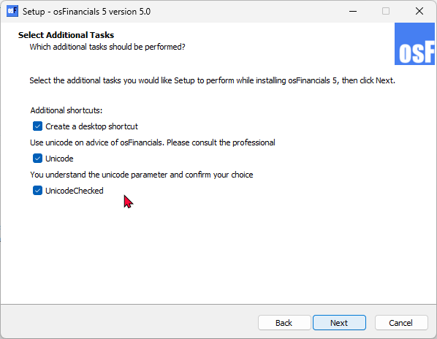

This will cause the MSSQL error, when opening a Set of Books (MSSQL database type).

***Unounicode=true***

If you do not check the **Unicode** checkbox (leave blank) and only select (tick) the **Unicode Checked** tick-box, the Unicode setting will be set as false in the osf.ini file:

*nounicode=true*

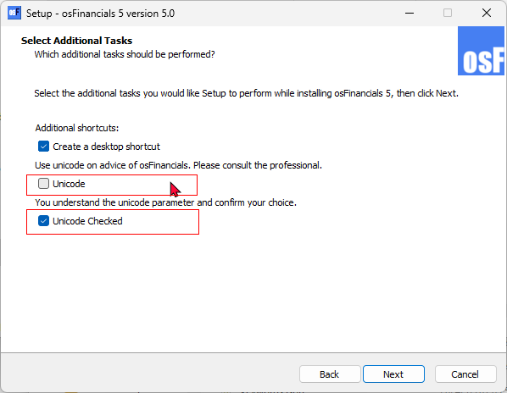

This will resolve the MSSQL error, when opening a Set of Books (MSSQL database type). Can open all Set of Books (MSSQL database type).

***Colours Select for Reporting groups***

**Setup → Groups**

Setting Colous in Groups does not change easily - MSSQL databases is more sticky than in Firebird databases

Cannot set the Account group 1 colours - Loses selected colours

Standard Theme palette - Hard colours - Cannot make softer colours using Custom colours

Debtor groups, Creditor groups, Document groups and Stock groups works but sticky - If the grids is open, you may select **Tools → Close active forms** and access the grid to display the colours.

***Customise Languages - Rest tab - Empty account / Empty Group***

Replicated in both Firebird and MSSQL databases.

The **Customise languages - Rest** tab does not store "*Groups empty account*" when you click on the **Change** button (second button).

It displays "*Empty account*" from the first "*Description of Zero account*". It does not save correctly.

Difficult for translations or customisation.

Need to change the first **Change** button and confirm to change it to for example no group have to enter "*No group"* and click **Change** (second button). Thereafter need to reopen the Set of Books for changes to have an effect.

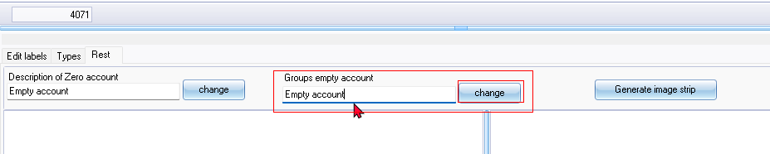

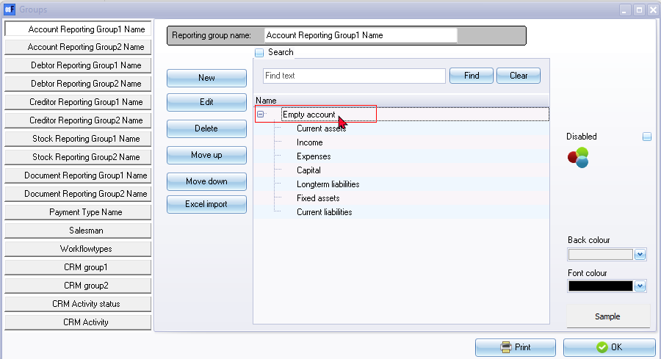

**Budgets MSSQL Error**

Entering **Budgets** (**Reports** ribbon) and click on the **Apply to selection** button produces the following error:

*Incorrect syntax near 'a'.*

On **Setup → Accounts** you can enter budgets

**Access control**

***Posting / Delete buttons***

Need to update documentation

**Access control - Documents** tab - Document posting tick-box - Add **Posting** and **Delete** buttons to the Documents grid sidebar. Does not work for single users - Need to setup users before this Document posting will be available for a user.

It is just a entry in the database with user id 0

***Default language for a Set of Books***

In Firebird and MSSQL database types cannot change the language on **Setup → Access control** (System language) and click the **Apply** button as the default language for the Set of Books. It reverts back to the original language e.g. Afrikaans if you change it to English.

Workaround - You have to use the **Switch language** option on the **Start** ribbon to update the **System language** in **Setup Setup → Access control**.

Language can be set at user level. So user a can login with language a and user b with language b

**System language** - Default language for the Set of Books

Language - Cannot select a language (empty / blank). You need to use the Multi-language Set of Books plugin ([Manual](https://www.osfinancials.org/en/plugin-manuals/515-multi-language-plugin) - [Shop](https://www.osfinancials.org/en/webshop/accountancy/multi-language-set-of-books) ) to select a language added in the [**Setup → Groups - Languages**](hnd-topic://ea415ae8eed341c98609503897aa45c6) reporting group.

**Access Violations - Reports**

***Ledger analyser - Balance sheet***

Produces Access violation error

*Access violation at address 525C8283 in module 'rtl290.bpl'. Read of address 2E300858*

Balance sheet prints after second attempt

***Graphs***

Some Graphs print Access violations click 1 or sometimes 2xtimes then it prints.

***Cost centres***

Cost centres were producing similar Access violation errors in the Balance sheet and some reports. Need to click 1 or more tipes then the report prints.

**Export - Accounts**

***Spreadsheet import - Accounts***

* Spreadsheet export import - No Sub-accounts Workaround delete accounts and recreate accounts.

* Export (Setup ribbon) Export tab txt file imports well - Need to delete the first tax account (No tax tab) and zero-rated items.

You can check the Tax percentages (User reports **→** Tax to see incorrect tax percentages such as the first Tax code (sub-account), which does not incluse a Tax tab and percentage.

***Import Stock***

Stock - Import - Tab-delimited .txt file

*The statement has been terminated. - Tab delimited *.txt file  
The INSERT statement conflicted with the FOREIGN KEY constraint "FK_DOCLINE_STOCK". The conflict occurred in database "MSSQL-TOETS-NUTSMAN", table "dbo.Stock", column 'WStockID'.*

Spreadsheet Export from Firebird databases and Import to MSSQL works.

**Imported Batches**

Replicated in both Firebird and MSSQL Database types.

**F8: Batch list** Empty accounts on the Unposted batch report.

Balancing the batch will print only the balanced accounts - need to reselect or confirm the imported accounts

Reselect the accounts - list on Batch **F8:List** Unposted batches report.

**Bank import - Import Bank statement**

***Delete Bank account with Posted transactions***

Bank statement - Import Account from spreadsheet - Cannot delete bank account

*The statement has been terminated.  
The DELETE statement conflicted with the REFERENCE constraint "FK_TRANSACT_ACCOUNT". The conflict occurred in database "MSSQL-MY-BOOKS", table "dbo.TransAct", column 'WAccountID'.*

If you have posted transactions to a bank account, you first need to cancel reverse posted batch and erase the batch to process the import bank statement

Similar errors in Firebird databases.

***Bank-Import Open Item link***

When allocating transactions for an Open item account, the Open item selection screen.

*The statement has been terminated.  
The INSERT statement conflicted with the FOREIGN KEY constraint "FK_OILINKSPRE_BATCH". The conflict occurred in database "MSSQL-MY-BOOKS", table "dbo.BatCon", column 'WBatchID'.*

**Imported Documents**

Document Export Import plugin used to export documents from a Set of Books (Firebird Database). Imported into a Set of Books (MSSQL database).

***Import Exported documents***

***Financial entry***

Financial Entry - Need to reselect the Ledger Account and confirm it is correct.

Can select a main account (with sub accounts).

Tax by default looks like the Tax is codes is correct, Tax amount on Documents grid - When opening the document the tax code may be blank. Need to select the correct tax code.

***Update Documents***

When updating documents, some errors were replicated in MSSQL databases. Some of these similar errors is replicated in Firebird databases.

*Fault in rounding please set your rounding margin document:AK000001 of 150  
You cant post to the zero tax account!*

Need to select the correct Tax account.

*AK000001 Algemene Grootboek 1000 0*

Financial Entry - Imported Documents - Need to select a Ledger account